Water Clear Polyester Casting Resin
Materials
The materials needed for clear casting are water clear polyester casting resin, catalyst (hardener), measuring syringe, plastic mixing cups and a mould. Opaque or translucent pigments can be used to colour the resin if desired. Wet and dry paper, and polishing compound, will also be useful to finish off the casting. Finished castings can be filed or sawn, A protective mask should worn to shield the eyes and mouth.

THESE MATERIALS ARE UNSUITABLE FOR USE BY CHILDREN UNLESS UNDER SUPERVISION.

Almost anything can be embedded in clear casting resin. It can be used to produce attractive paper weights and other ornaments, pendants key rings, and display items. Clear casting is an ideal means of preserving medical and biological specimens.

Moulds specifically designed for clear casting are available, but you can also use polythene cartons, often used as freezer food containers in shops. Polystyrene containers cannot be used. Moulds can be constructed from wood, glass and melinex covered card. Silicone rubber moulds can be used but for best results, we recommend 'addition cured' silicone. Rigid moulds should be wider at the top for easy removal.
Preparing Specimens
Biological specimens-insects and other small animals contain natural oils which must be removed before embedding. This can be done by dipping in acetone solvent and thorouhly dried. Flowers also need to be carefully dried.
The simplest method is to place the flower on a layer of dry white sand in a container. More sand sprinkled around the flower until it is covered, and it is then left for three days in a warm dry atmosphere. It can then be removed and sealed with polyurethane varnish or hair lacquer.

Flowers sometimes tend to change colour, due to the dyes being affected by the resin. Flower preserving chemicals for can be obtained from your local chemist. Stamps and other paper items should be sealed with a thin coat of polyurethane and dried before embedding. Coins, etc., need no special treatment as long as they are clean and dry.
Method
Pour a little resin into a mixing cup and leave to allow air bubbles to rise. Carefully stir the required amount of catalyst into the resin. The normal working proportion of catalyst is 1% by weight (ie. 10ml catalyst to 1kg resin) but this can be increased to 2% for very small quantities of resin, or in low working temperatures. It is important not to use too much catalyst, which may result in the casting becoming cracked or discoloured. Pour the resin into the mould to form a base layer, cover the mould to protect from dust, and leave to harden. After about 40 minutes at 20ºC, it will have reached a firm jelly-like consistency. Place the specimen on the base layer. Very light specimens will tend to float and need to be glued to the base layer with a drop of resin. Mix up a further quantity of resin and pour around the specimen. In a very small casting the specimen can be covered in one pouring, but it is

generally better to build up the casting in a series of layers. A large casting done in one pouring may generate too much heat and crack. Metal and solid objects generally, tend to expand or contract at a different rate from the resin, which can result in a crazy effect. When the final layer of resin has gelled (set firm), cover it with a sheet of cellophane or melinex to exclude air, otherwise it may set with a tacky surface. When fully hardened, the casting can be removed from the mould.

Finishing
Any surface tack can be removed with neat washing-liquid, followed by a rinse in warm water. This should not be done until the resin is fully cured (about seven days). After complete cure the casting can be shaped further with hacksaw, file or sander to cut roughly to shape. Then use wet and dry paper, starting with a coarse grade and working through to finer grades, finally polish with compound

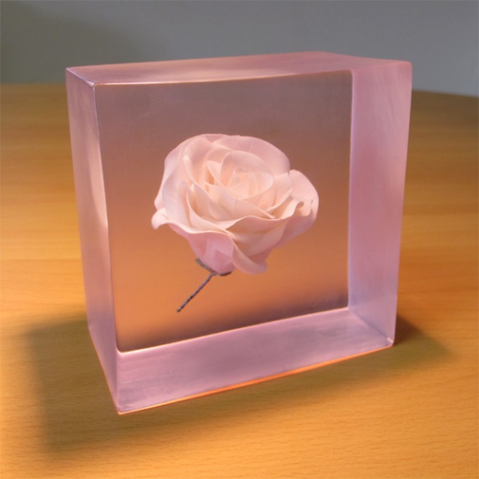
Flowers sometimes tend to change colour, due to the dyes being affected by the resin. Flower preserving chemicals for can be obtained from your local chemist. Stamps and other paper items should be sealed with a thin coat of polyurethane and dried before embedding. Coins, etc., need no special treatment as long as they are clean and dry.

Mixing Catalyst
Thorough mixing of catalyst into resins and gelcoat is very important. Also the correct additions should be observed to maintain good results. Dispensers are advised for accuracy. The table below gives the correct ratios of catalyst to resin and gelcoat by weight. 1% is considered a slow mix, 2% is ideal, 3% is a fast mix. Additions outside these bands in not advisable for proper curing, in fact adding more than 4% may result in a failure to cure. The pot life of these mixes is also determined by temperature. The higher the temperature the faster the cure. As a general guide 2% addition at 20ºC gives 15-20 minutes pot life. The resin will always cure quicker if left in a mass such as the mixing bucket or in castings.
Catalyst Mixing Ratio
RESIN WEIGHT
Addition of Catalyst (ml) | 50g | 100g | 250g | 500g | 1kg | 5kg
1% | 0.5 | 1 | 2.5 | 5 | 10 | 50
2% | 1 | 2 | 5 | 10 | 20 | 100
3% | 2 | 3 | 7.5 | 15 | 30 | 150

For measuring we supply a 10 ml syringe or 15ml & 80ml dispenser bottles.
For measuring tiny amounts, a medical eye-dropper may be used. A plastic teaspoon, not metal, can also be used. 1 tsp. = 5ml

